# **5.4 Guided Exercise: Enabling BitLocker**

|  |  |
| --- | --- |
| **Resources** | |
| Files | None |
| Machines | Windows 10 |

In this exercise you will enable Bitlocker to encrypt the hard drive.

Login to Windows 10 and once logged in click on the Start button and in the search box write gpedit.msc and press enter.

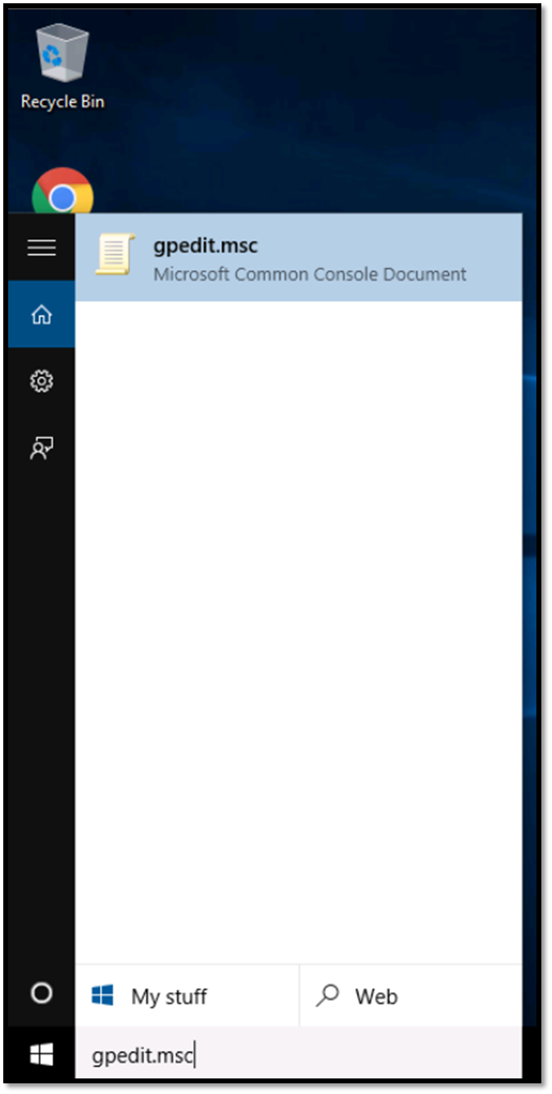

On the Local Group Policy Editor window expand from Computer Configuration -> Administrative Templates -> Windows Components -> BitLocker Drive Encryption -> Operating System Drives.

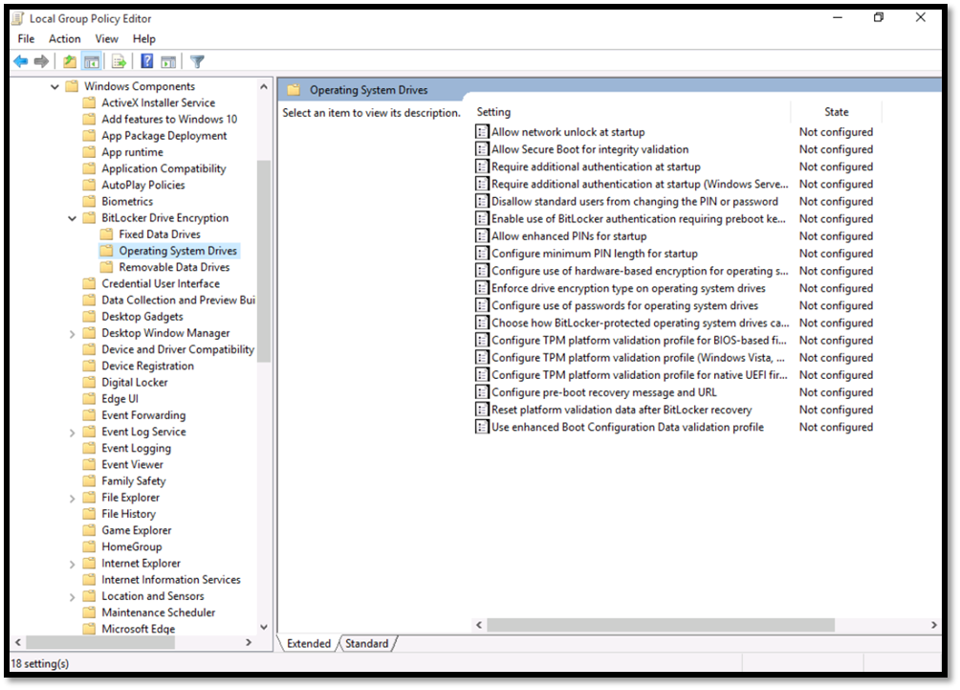

Double click the option Require additional authentcation at startup and on the new window that will open click Enabled (Make sure the box Allow BitLocker without a compatible TPM is ticket)and then Apply -> OK. After that close the Local Group Policy Editor window.

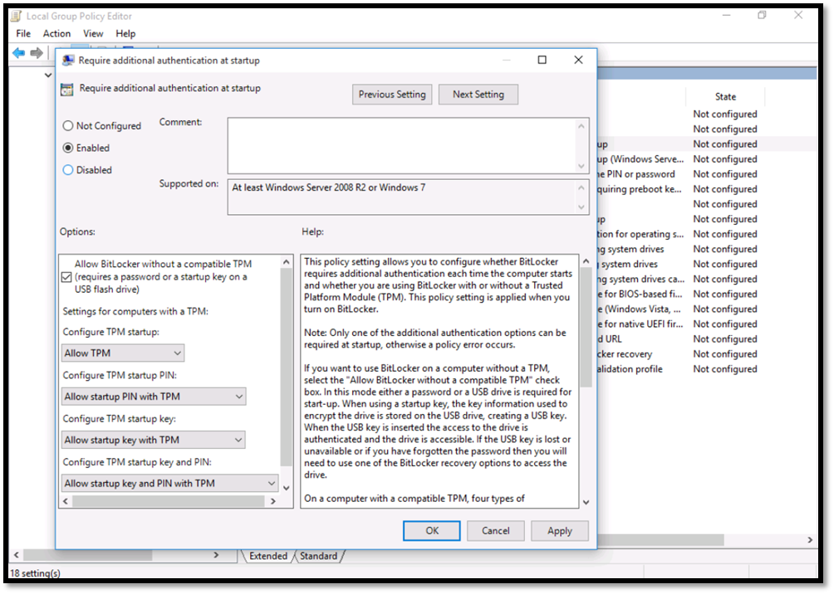  
Open file explorer and click on This PC. Right click on the Local Disk (C:) and click on the option Turn on BitLocker.

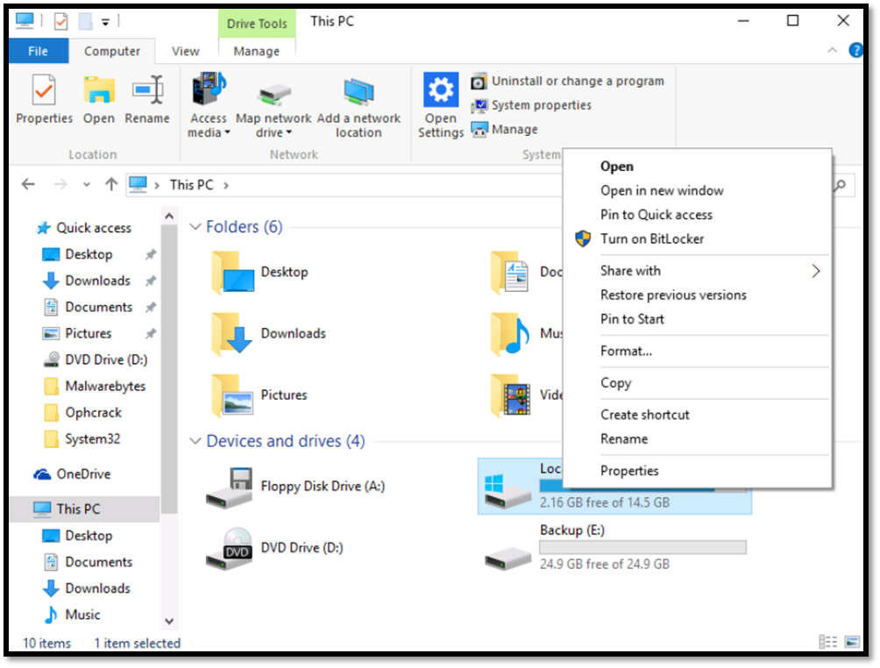

BitLocker will verify that the computer meets the requirements and will ask how to unlock the drive at startup. Choose the option Enter a password.

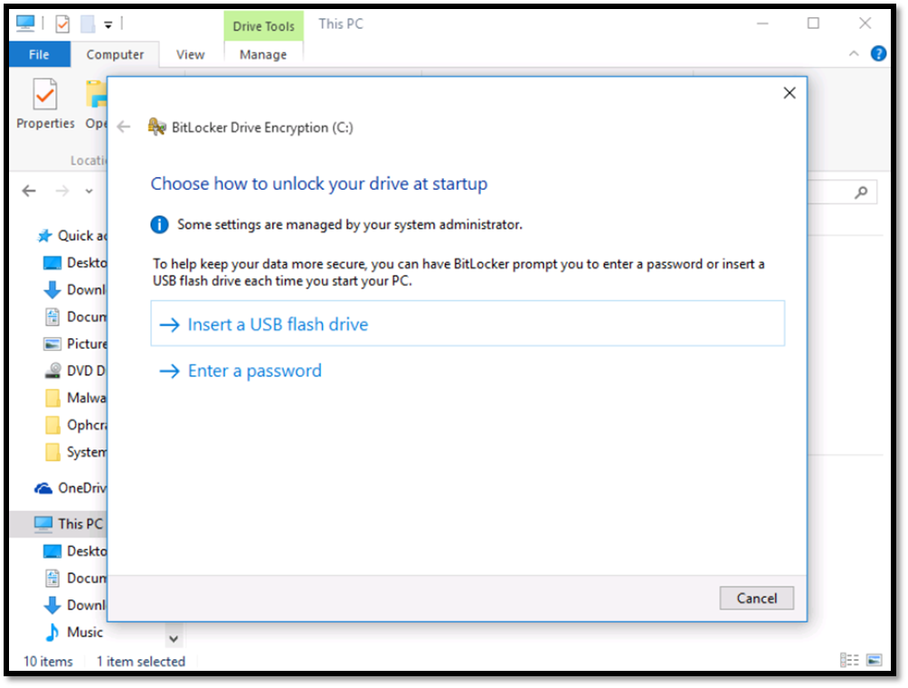  
Enter a password which is at least 8 characters long with uppercase and lowercase letters, symbols and spaces.

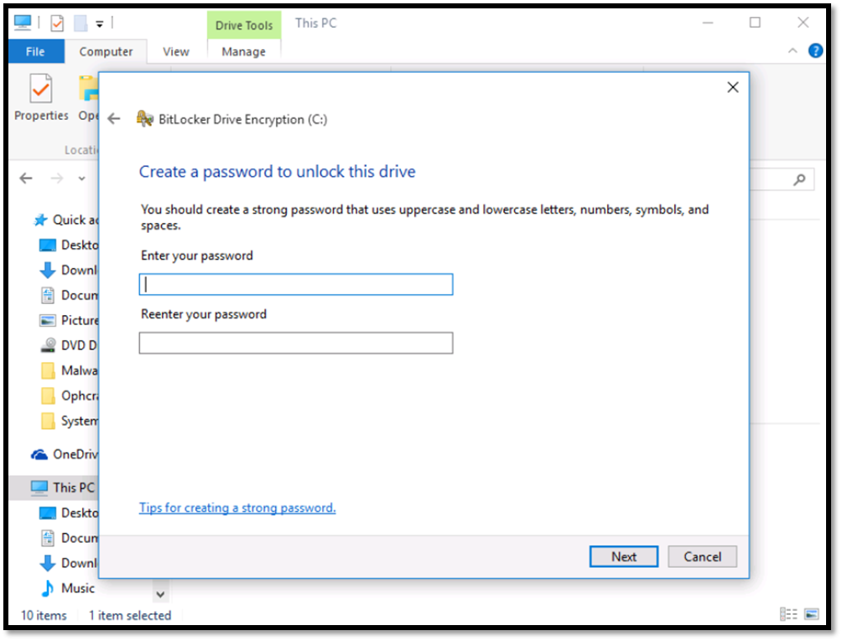  
Then you should save (backup) the recovery key. You can save the recovery key to a USB flash drive, print it, save it to a file or to your Microsoft account. For this exercise choose the option to print the recovery key.

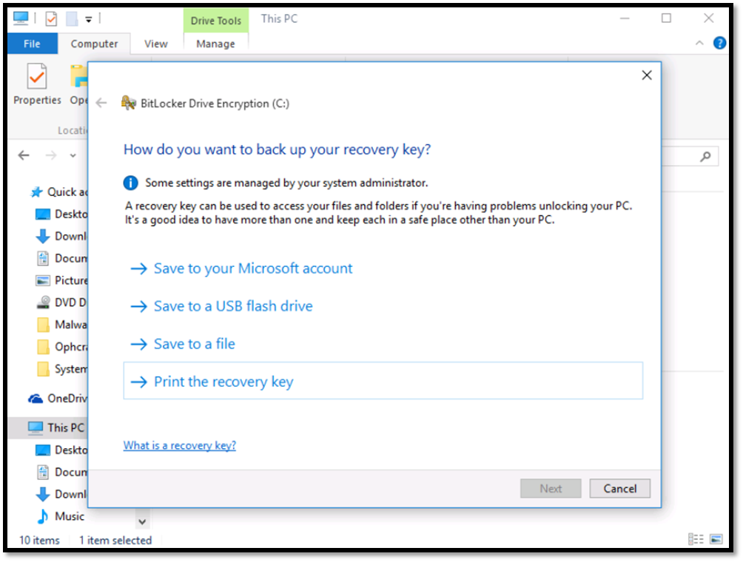  
On the Print window select the option Microsoft Print to PDF and click Print.

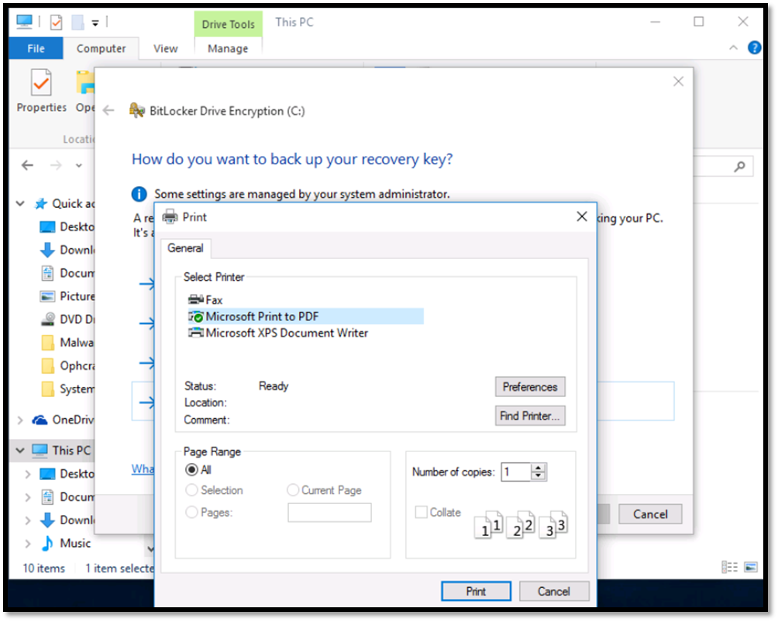  
Provide a file name for the recovery key (BitLocker Key for example) and save it to the Backup (E:) drive. Click Save and then OK. Then it will ask you to Run BitLocker system check. Uncheck the box (although you can leave it to run a check) and click Start encrypting.

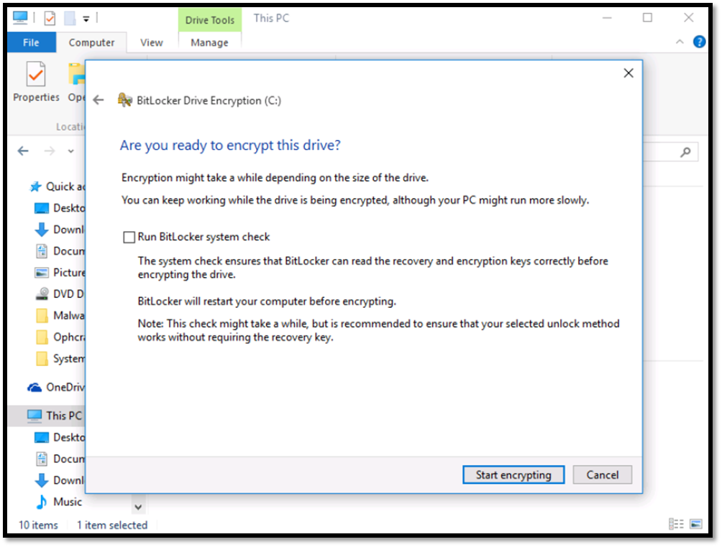  
The encryption process will take some time to finish, although if you have a large SATA disk such as 1TB, it will take a long time to finish where SSDs take less time.

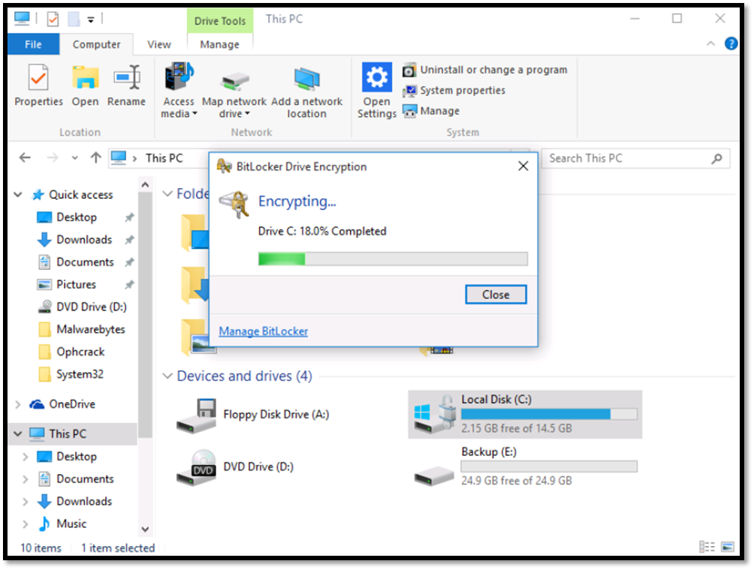  
Click Close once the encryption process has finished.

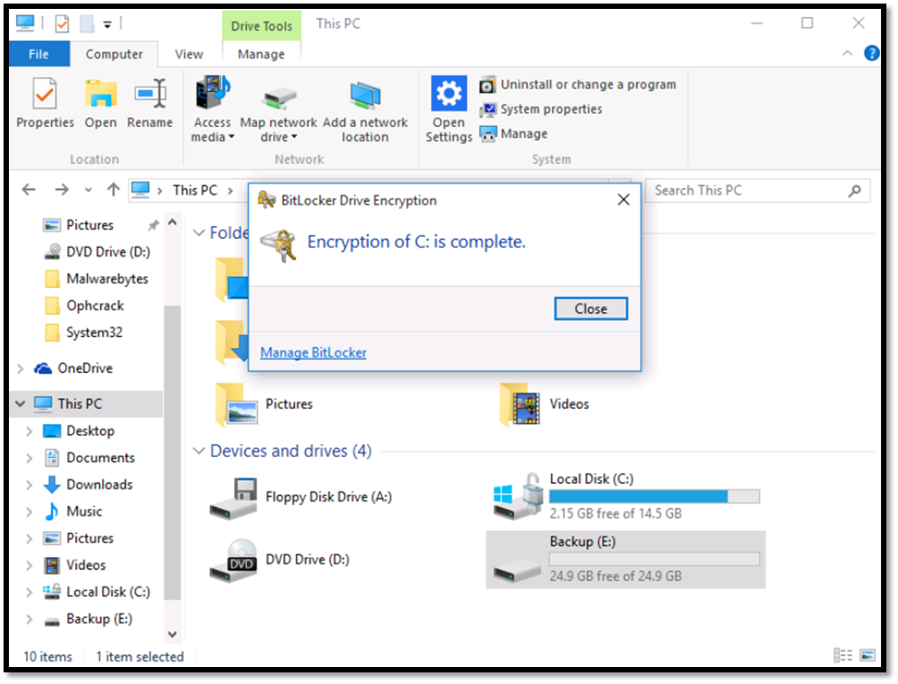

Restart the computer to confirm that once it starts asks for the BitLocker password. Enter the password and then press enter.

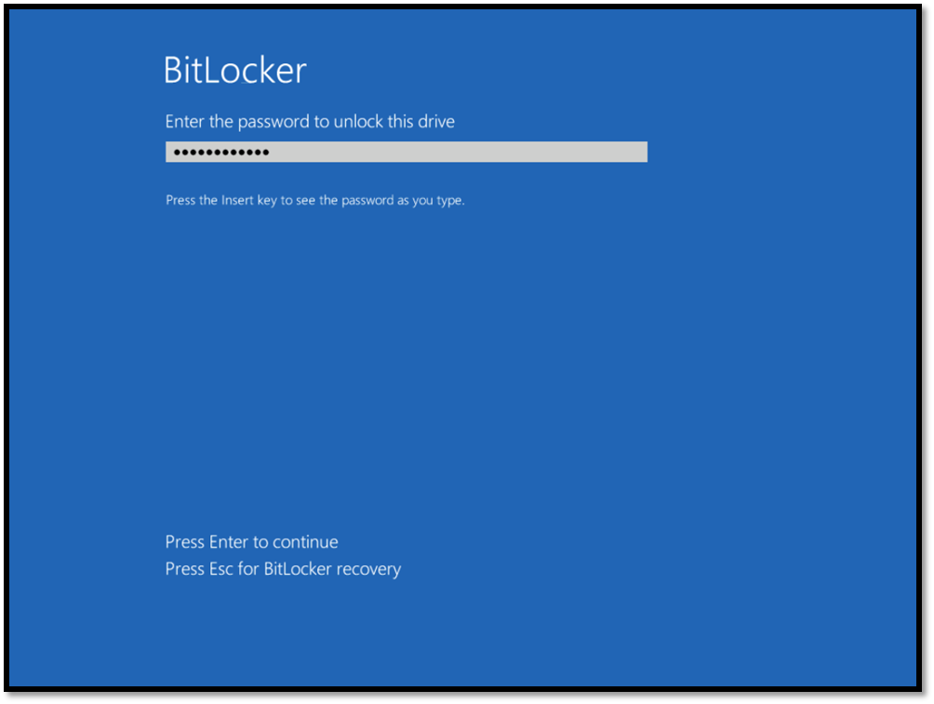  
Then the computer will ask for the password to login.